**Installation GUIDE-RUNNING & Developing AUTOMATION SCRIPTS**

Contents

**Setting up the Folder Structure** 3

**Folder Structure** 3

**Below are files used for Automation Scripts Development** 4

**Environmental File** 4

**Test Case File** 4

**Object Repository** 6

**Test Data File** 7

**Test Suite File** 8

**Executing the runs** 10

**Reporting Structure** 12

**Setting up the data to run multiple data sets** 13

**Checking the Reports** 16

**Mail Report** 18

Aim: The purpose of this document is to explain the process to run the automation scripts.

# **Setting up the Folder Structure**

**Download Automation Setup from below path:**

[Shared](https://drive.google.com/drive/u/0/folders/1AvmvOh862eVacZpUebQiafvjCtHt9uX0) Drive Location

Copy the downloaded files in any specific path

## **Folder Structure**

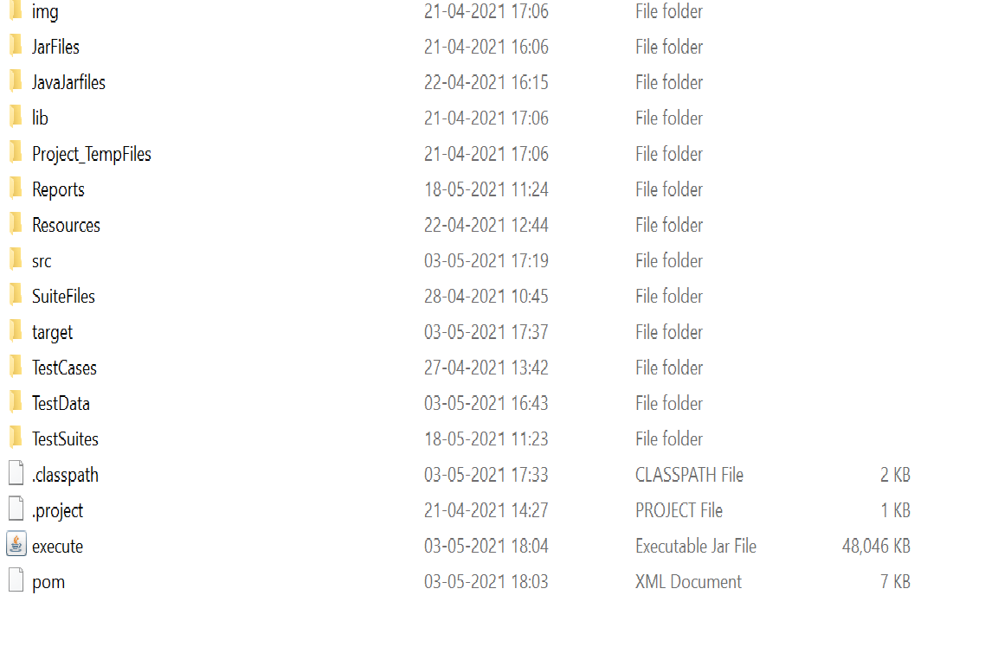

# **Below are files used for Automation Scripts Development**

* Environment File
* Test Case File
* Resources/Object Repository
* Test Data File
* Test Suite File

## **Environmental File**

Need to provide Application details like URL, username, password in environmental file.

Note: we can have all environments details here like QA, UAT, Prod clone…

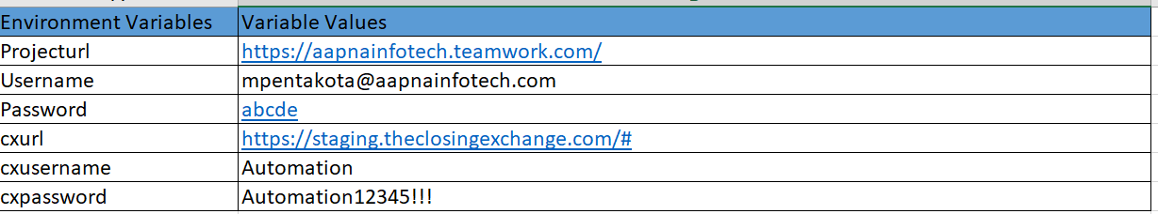

## **Test Case File**

Click on the Test Case folder in the folder structure and we can see all available Application cases

Click on any Folder we can see all the test cases for that particular Application

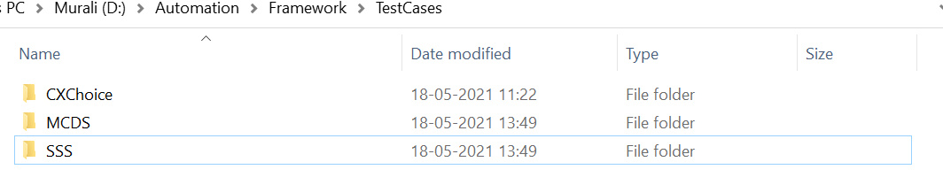

After clicking on any of above folder we can find the test cases as below

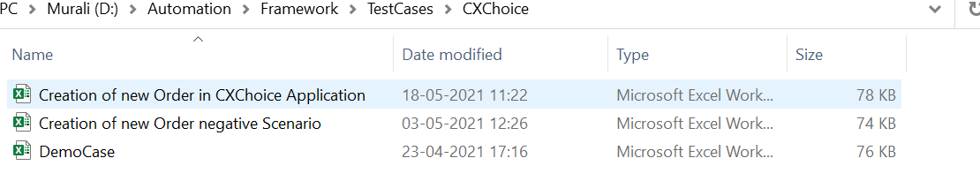

**Development of new test case:**

Test case sheet has 3 columns

1. KEYWORD
2. Label Name
3. Data

**Keyword:** keywords are nothing but functions which will do a specific task. Below are few examples

Launch Browser, Enter Value, verify value, click, mouse over, waitforelemet….

**Label Name:**  Name on the application. Below are few examples

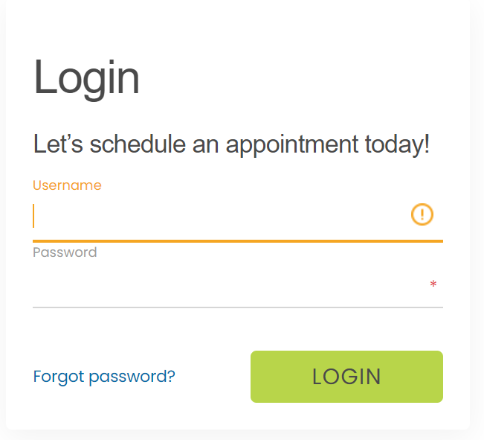

Label Names like Username, Password, LOGIN…

**Data:**  Functional data wherever necessary must be given in the 3rd column (Data)

For EX: please see the below screen shot, need to feed the functional data according to the requirements

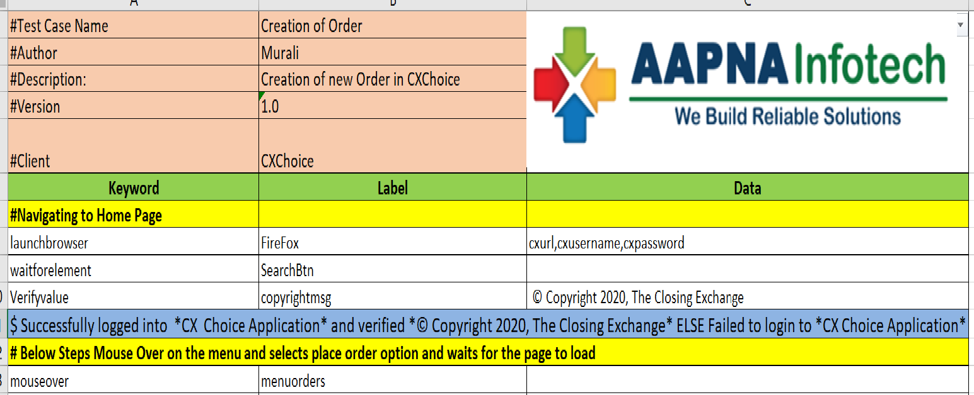

**Key Points on Color Formatting:**

* Any line in test case sheet can be commented out with the symbol ‘ **#** ‘
* As a process we are following yellow color for comments (The line should start with “#” symbol). We can add our comments like test step description or anything to be highlighted.
* We can have customized report statements. Can add report statements wherever necessary
* Reports lines are highlighted in blue color (line should start with symbol ‘ $ ‘.
* Report statement should be given with ‘ELSE’ like (PASS statement ELSE FAIL statement)

EX: $ successfully logged into application ELSE failed to login to application

* If any dynamic value to be present in the report, then we will call the variable name within the ampersand’s (**&)** as in above screenshot

## **Object Repository**

Object Repository placed under Resource’s folder

* All the xpaths of the elements need to be added in Object repository file.
* Note: the name of the xpath should be same as label name given in test case sheet
* All the elements of the page should be added under same page name

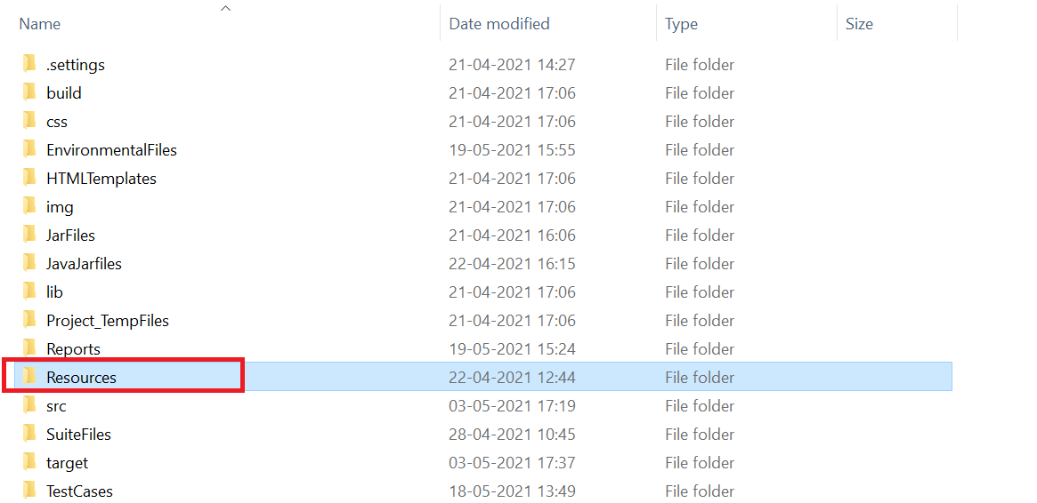

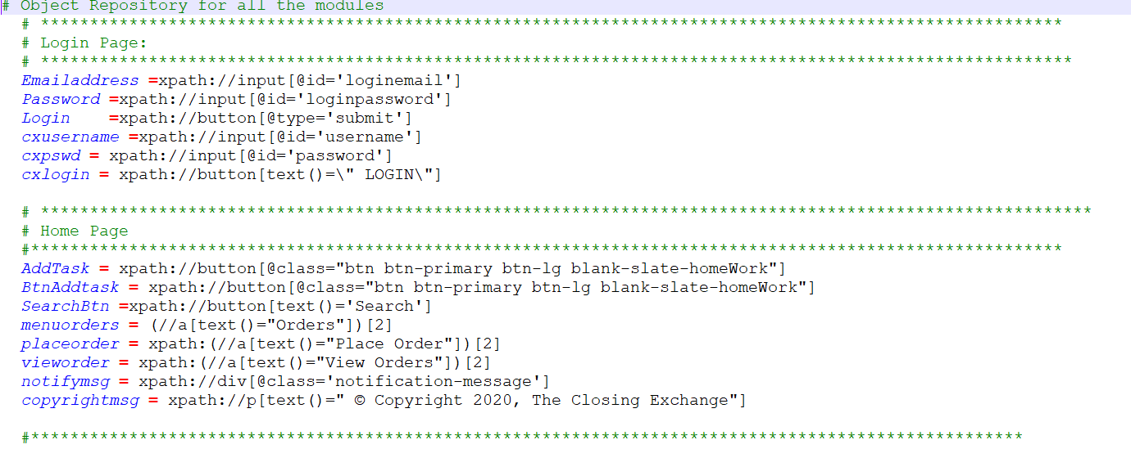

## **Test Data File**

This test data file preparation is optional.

Test Data will be of two types

1. Read Test Data
2. Create Test Data

* **Read Test Data**
* In this sheet we will prepare the data only when we want to use any specific data for multiple times or data need to use across application (Global data)
* We will store the data in in the variables and these variables will be called in the input sheets.

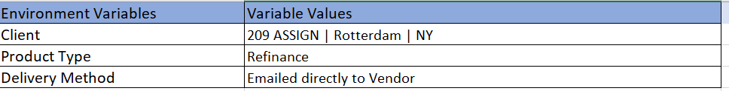

Here the variable names Client, Product Type and Delivery method can be used across all test cases

In order to use this data, we must ensure that for this folder path given in the Test Suite file should be set to Yes and use ReadTestData in the Test Case Name.

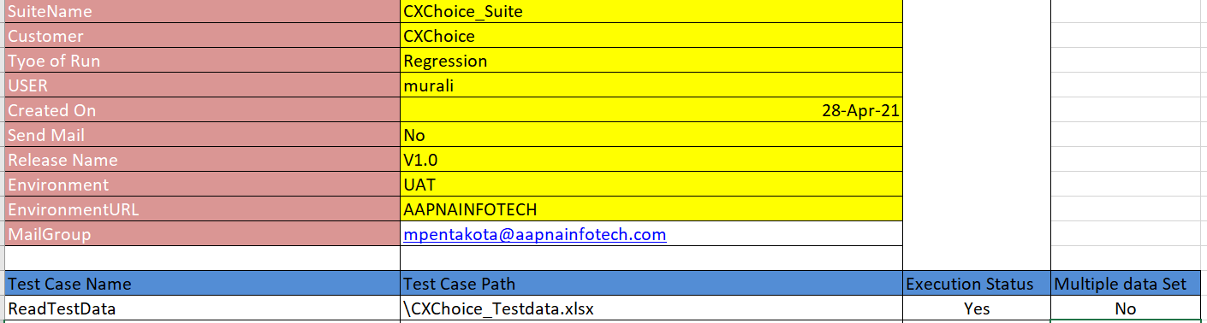

* **Create Test Data**

Similarly, we use CreateTestData instead of ReadTestData to create the test data for future use.

For this no need to prepare any test data as it will create data dynamically after every run overriding the existing ones.



## **Test Suite File**

Click on the Test Suite folder in the folder structure we can see all available Application Suites.

Click on any Suite name that needs to be executed

**Development of new test Suite:**

We can see 4 columns, keep execution status as YES for the test cases that need to be executed and NO for cases that not be executed.

4th column multiple data set, keep status as YES that need multiple data sets or simply NO

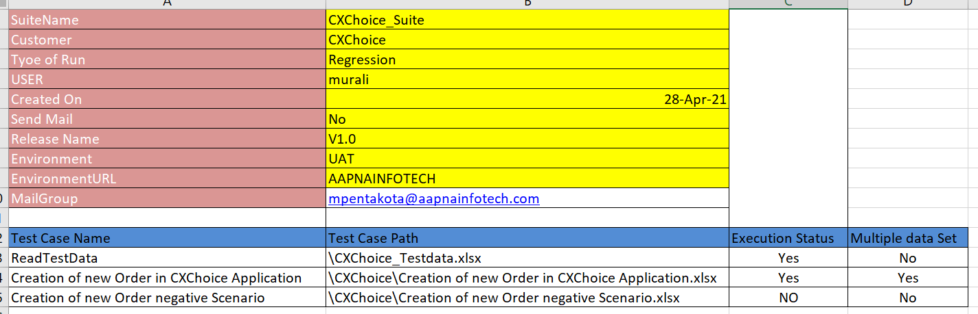

User will get the reports directly to the mail by setting the Send Mail Value to Yes and can include the multiple mail lists separated by comma in the Test Suite sheet as below

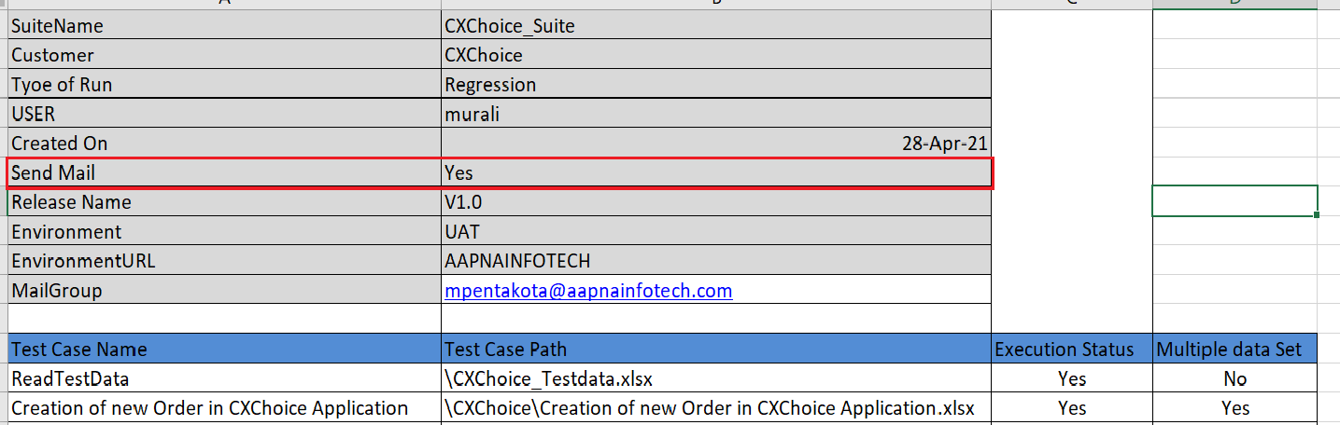

After execution we can see the reports in the **Reports Folder**

Click on the Reports folder to view the reports

Report name will be same as Suite name with current date and time stamp

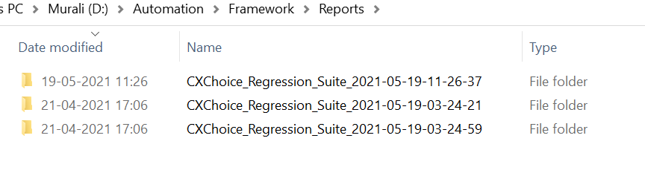

Click on the folder it will navigate to HTML pages, click on Main Page to see reports

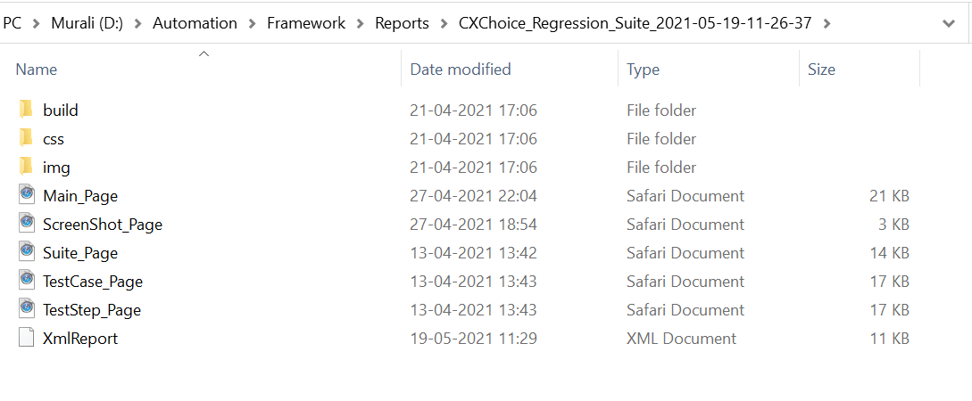

# **Executing the runs**

**Execution can be done in two ways:**

Click on the jar file or we can run from net beans/eclipse

1. **Running through Jar file:**

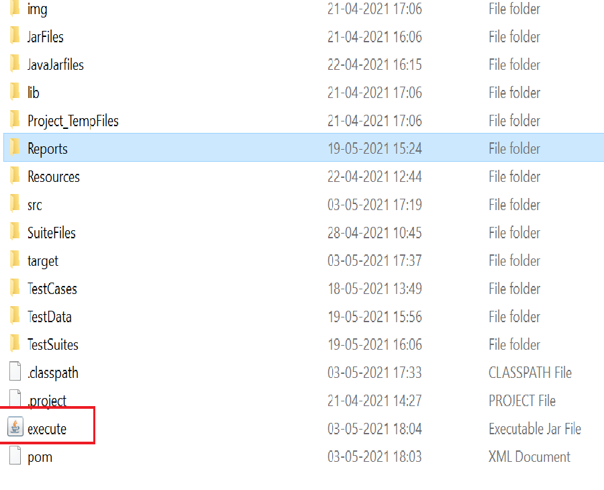

**Running through eclipse/NetBeans**

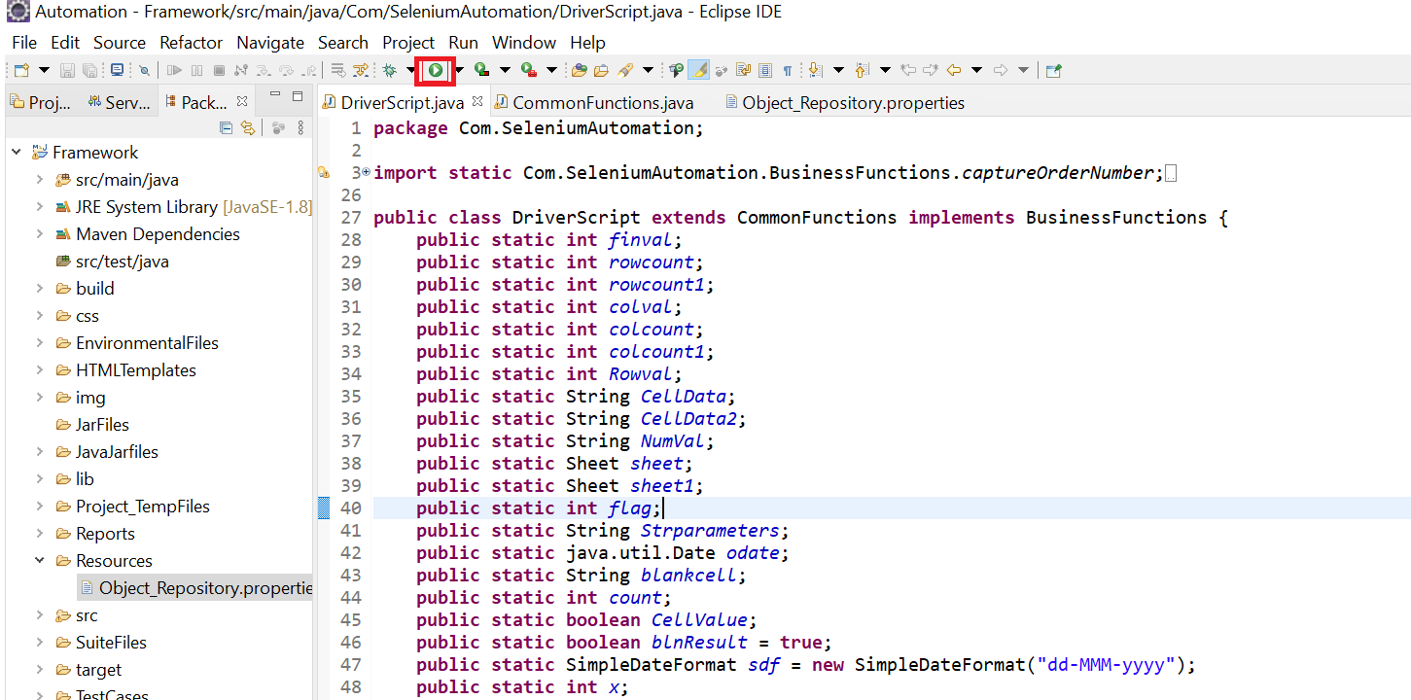

# **Reporting Structure**

The test Steps to be displayed in the report should be provided in the test case sheet.

The row starting with “$” represents the reporting instructions in which can be customized according to the requirement.

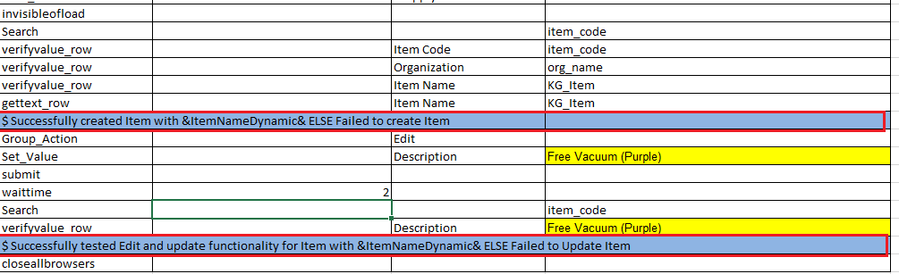

Pass or fail instructions to be displayed in the output report link is separated with **ELSE**

From $ to ElSE it will be considered as Pass report rest will be considered as Failed report.

If any dynamic value to be present in the report, then we will call the variable name within the ampersand’s (**&)** as in above screenshot

# **Setting up the data to run multiple data sets**

Filter the 4th column and uncheck the blanks

Click on OK button

Open the required Input sheet

1. Filter the 4th column and uncheck the blanks
2. Click on **OK** button.
3. Then the sheet will be filtered without blank fields

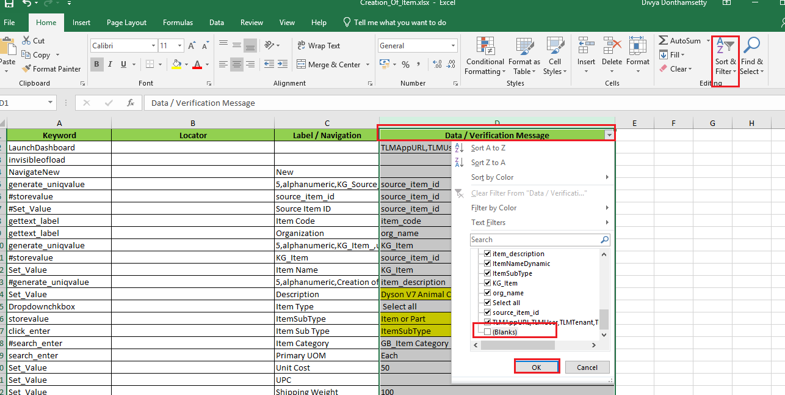

1. Copy entire column 3 & column 4

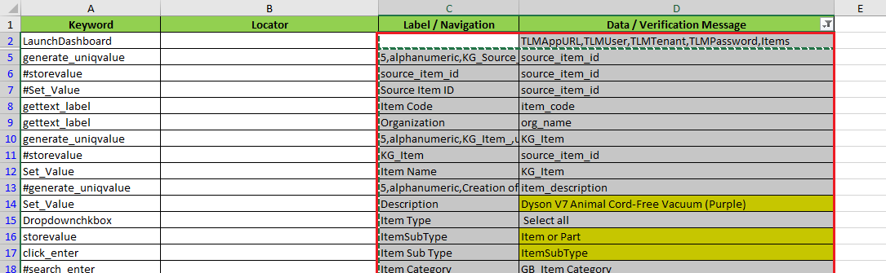

1. Paste (right click) this in the second sheet by selecting Transpose as below

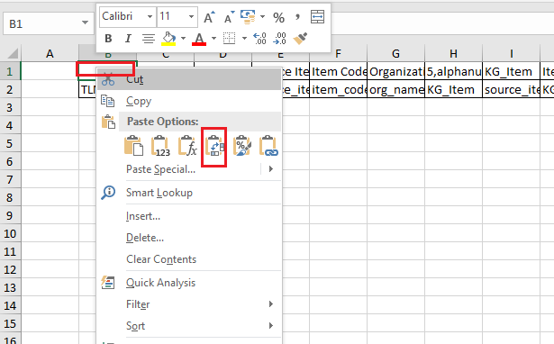

1. In the Column A add the Test Case Name that will reflect in the reports.



1. Now unselect the filter and save the sheet.



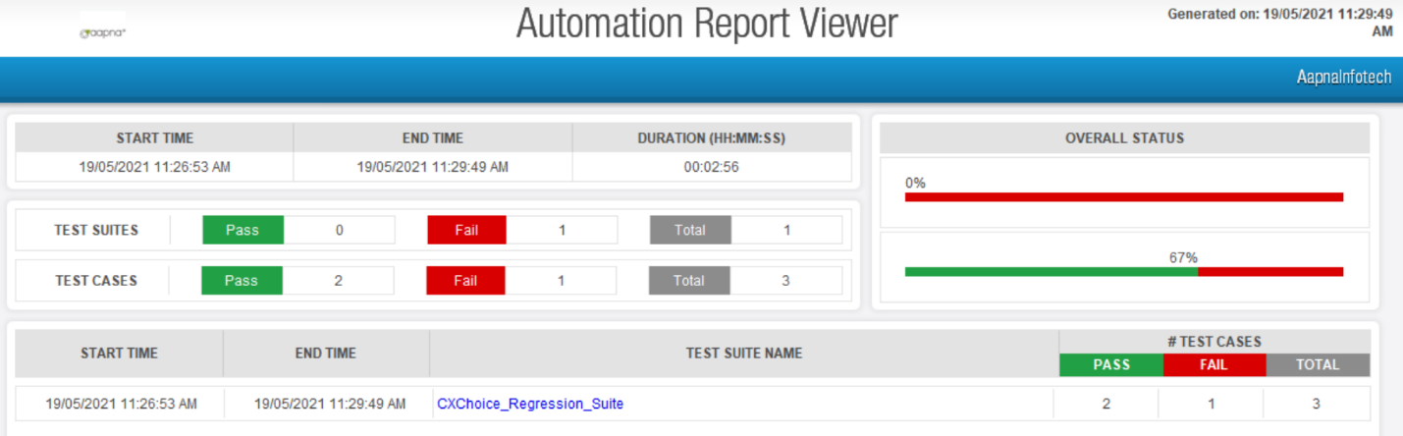

# **Checking the Reports**

Click on the Test Suite Name. You will see all the reports as below.

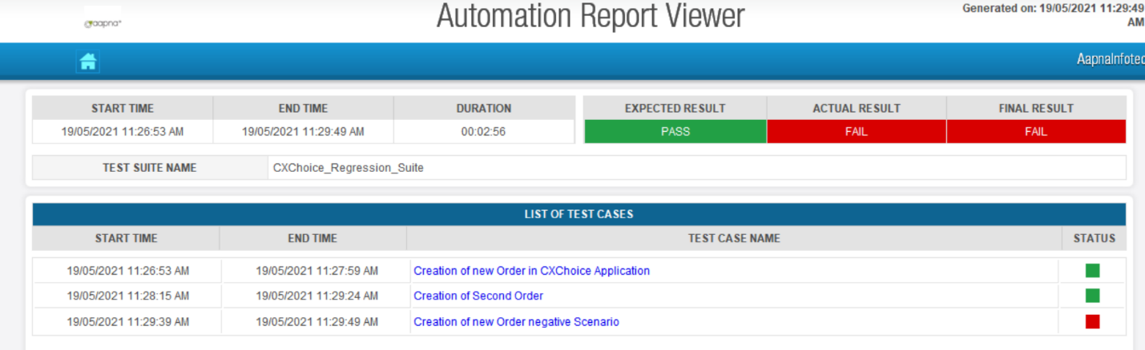

Click on the Pass or Failed Test Cases which you want to view.

Passed Results will be as follows

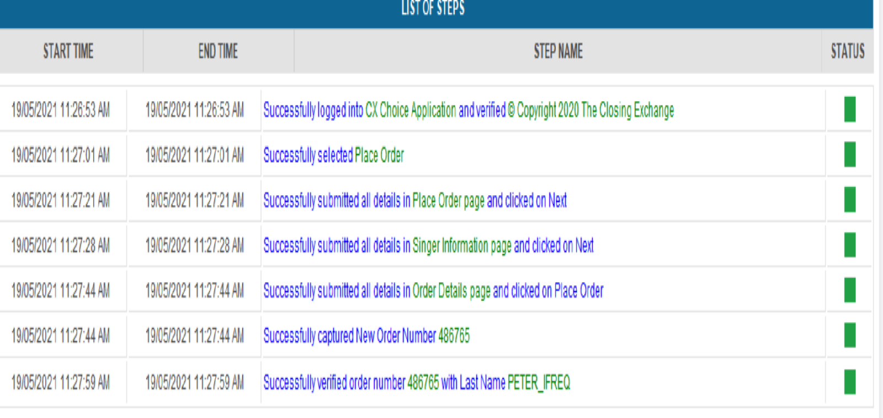

Failed Results will be as follows:

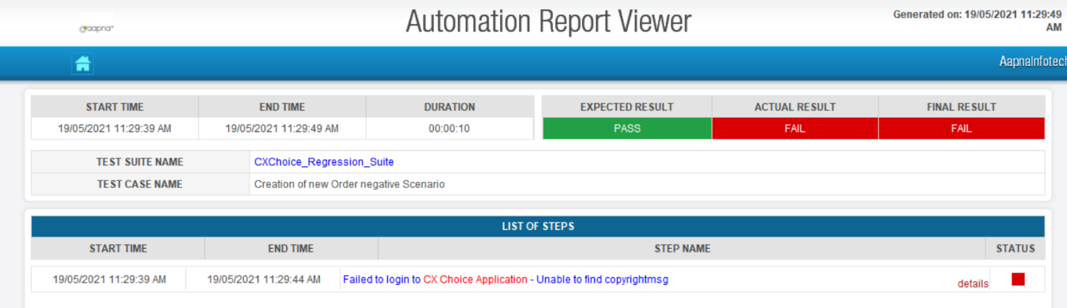

Click on the details link beside the failed step and it will navigate to screenshot page.

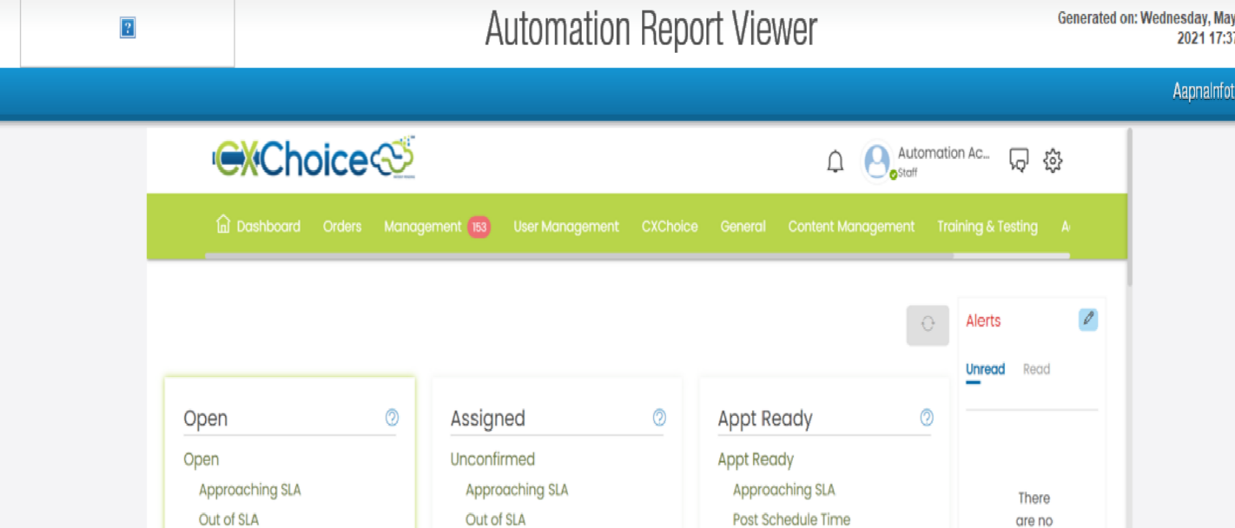

# **Mail Report**

Along with the reports Mail will be triggered after completion of the execution with all the test results like pass/fail count, schedule time, Test Case Name, Failed Comments, URL, Report link, excel file consolidated etc., as shown below.

User will only get the reports directly to the mail by setting the Send Mail Value to Yes in the Test Suite sheet. The details to be displayed in the mail will be provided in the Test Suite file as below

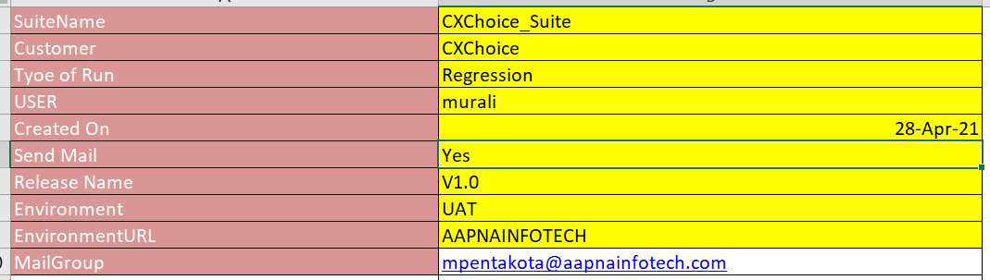

Mail will be triggered for all mentioned in sheet.

The details will also be included in the attachment sent in the mail as below.